Experiment Number : 04 Date: 5-2-26

ARRAYS
Aim:
To understand and implement array operations in Java.
PRE LAB EXERCISE
QUESTIONS
- What is an array?
An array is a data structure that stores multiple values of the same data type in a single continuous block of memory.
Each value is stored at a specific position called an index.
Example:
int marks[5]; → stores 5 integer values.
- Why are arrays used?
Arrays are used because:
- To store multiple values together
Instead of creating many separate variables, we can keep related data in one structure.
- Easy to access elements using index
Example: marks[2] gives the 3rd element.
- Efficient memory usage
Data is stored in contiguous memory, making access faster.
- Useful for loops and algorithms
Arrays make sorting, searching, and processing data easier.
- What is the difference between array and variable?
Variable | Array
Stores only one value at a time. | Stores multiple values of the same type.
Has one memory location. | Has multiple consecutive memory locations.
Example: int x = 10; | Example: int a[5] = {1,2,3,4,5};
Cannot hold a list of items. | Can hold lists (marks, ages, numbers, etc.).

IN LAB EXERCISE
Objective:
To perform array operations using simple programs.
PROGRAMS:
1. Program to Read and Print Array Elements
Code:
package tutorial;
import java.util.Scanner;
public class read {

public static void main(String[] args) {
Scanner sc = new Scanner(System.in);
int[] arr = new int[5];
System.out.println("Enter 5 elements:");
for(int i = 0; i < 5; i++)
arr[i] = sc.nextInt();
System.out.println("Array elements are:");
for(int i = 0; i < 5; i++)
System.out.print(arr[i] + " ");
}
}

OUTPUT:
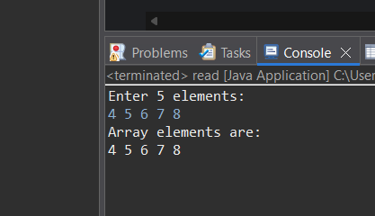
2. Program to Find Sum of Array Elements
Code:
package tutorial;
import java.util.Scanner;
public class sumo0farray {
public static void main(String[] args) {
Scanner sc = new Scanner(System.in);
int[] arr = new int[5];
int sum = 0;
System.out.println("Enter 5 elements:");
for(int i = 0; i < 5; i++)
arr[i] = sc.nextInt();
for(int i = 0; i < 5; i++)
sum += arr[i];
System.out.println("Sum = " + sum);
}
}

OUTPUT:
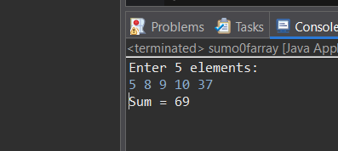
3. Program to Find Largest Element in an Array
Code:
package tutorial;
import java.util.Scanner;
public class larinarr {
public static void main(String[] args) {
Scanner sc = new Scanner(System.in);
int[] arr = new int[5];
System.out.println("Enter 5 elements:");
for(int i = 0; i < 5; i++)
arr[i] = sc.nextInt();
int max = arr[0];
for(int i = 1; i < 5; i++)
if(arr[i] > max)
max = arr[i];
System.out.println("Largest element = " + max);
}
}

OUTPUT:
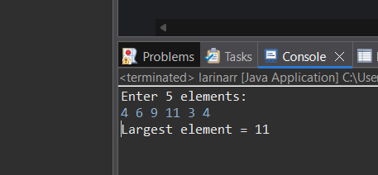
4. Program to Reverse an Array
Code:
package tutorial;
import java.util.Scanner;
public class revarray {
public static void main(String[] args) {
Scanner sc = new Scanner(System.in);
int[] arr = new int[5];
System.out.println("Enter 5 elements:");
for(int i = 0; i < 5; i++)
arr[i] = sc.nextInt();
System.out.println("Reversed array:");
for(int i = 4; i >= 0; i--)
System.out.print(arr[i] + " ");
}
}

OUTPUT:
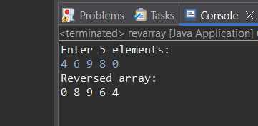
5. Program to Count Even and Odd Numbers
Code:
package tutorial;
import java.util.Scanner;
public class countev {
public static void main(String[] args) {
Scanner sc = new Scanner(System.in);
int[] arr = new int[5];
int even = 0, odd = 0;
System.out.println("Enter 5 elements:");
for(int i = 0; i < 5; i++)
arr[i] = sc.nextInt();
for(int i = 0; i < 5; i++) {
if(arr[i] % 2 == 0)
even++;
else
odd++;
}
System.out.println("Even = " + even);
System.out.println("Odd = " + odd);

}
}

OUTPUT:
Input:
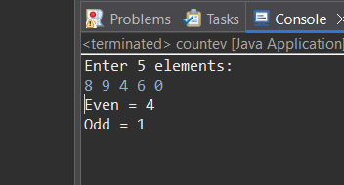

6. Program to Sort Array in Ascending Order
Code:
package tutorial;
import java.util.Scanner;
public class sort {
public static void main(String[] args) {
Scanner sc = new Scanner(System.in);
int[] arr = new int[5];
int temp;
System.out.println("Enter 5 elements:");
for(int i = 0; i < 5; i++)
arr[i] = sc.nextInt();
for(int i = 0; i < 5; i++) {
for(int j = i + 1; j < 5; j++) {
if(arr[i] > arr[j]) {
temp = arr[i];
arr[i] = arr[j];
arr[j] = temp;
}
}
}
System.out.println("Sorted array:");
for(int i = 0; i < 5; i++)
System.out.print(arr[i] + " ");
}
}

OUTPUT:
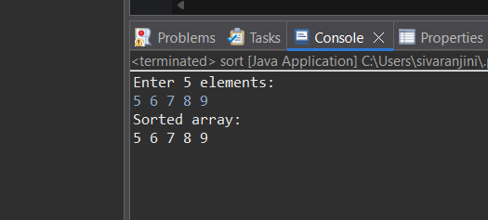
7. Program to Find Second Largest Element
Code:
package tutorial;
import java.util.Scanner;
public class secondlar {
public static void main(String[] args) {
Scanner sc = new Scanner(System.in);
int[] arr = new int[5];
System.out.println("Enter 5 elements:");
for(int i = 0; i < 5; i++)
arr[i] = sc.nextInt();
int largest = Integer.MIN_VALUE;
int second = Integer.MIN_VALUE;

for(int i = 0; i < 5; i++) {
if(arr[i] > largest) {
second = largest;
largest = arr[i];
}
else if(arr[i] > second && arr[i] != largest) {
second = arr[i];
}
}
System.out.println("Second largest = " + second);
}
}
OUTPUT:
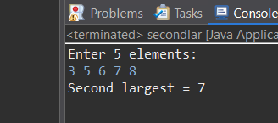
8. Program for Matrix Addition (2D Array)
Code:
package tutorial;
import java.util.Scanner;
public class addition {
public static void main(String[] args) {
Scanner sc = new Scanner(System.in);
int[][] a = new int[2][2];
int[][] b = new int[2][2];
int[][] sum = new int[2][2];
System.out.println("Enter elements of matrix A:");
for(int i = 0; i < 2; i++)
for(int j = 0; j < 2; j++)
a[i][j] = sc.nextInt();
System.out.println("Enter elements of matrix B:");
for(int i = 0; i < 2; i++)
for(int j = 0; j < 2; j++)
b[i][j] = sc.nextInt();
for(int i = 0; i < 2; i++)
for(int j = 0; j < 2; j++)
sum[i][j] = a[i][j] + b[i][j];
System.out.println("Sum matrix:");
for(int i = 0; i < 2; i++) {
for(int j = 0; j < 2; j++)
System.out.print(sum[i][j] + " ");
System.out.println();
}
}
}

OUTPUT:
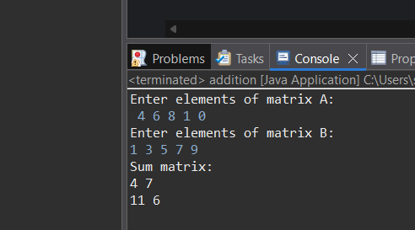

POST LAB EXERCISE
- Why is array indexing usually started from zero instead of one?
Array indexing starts at 0 because:
- Address calculation becomes simple:
EA = Base Address + (Index × Size)
If index starts at 0, no extra subtraction or adjustment is needed.
- Efficiency:
Zero-based indexing reduces computation and improves performance.
- Historical reason:
Early programming languages like C mapped the index directly to the memory offset.
So indexing from 0 is simpler and faster for the CPU.
- What happens if we try to access an array element outside its declared size?
Accessing an element outside the array range causes:
- Undefined behavior (in C/C++)
- Runtime error / Exception (in languages like Java, Python)
Example in Java: ArrayIndexOutOfBoundsException
This happens because you are trying to use memory not allocated for that array.
- How does memory allocation differ for static arrays and dynamic arrays?
Static Arrays
- Size is fixed at compile time.
- Memory is allocated in stack or global/static memory.
- Cannot resize after declaration.
Dynamic Arrays
- Size is decided at runtime.
- Memory is allocated from the heap.
- Can be resized using functions (like realloc or ArrayList in Java).
- More flexible, but slightly slower due to heap management.
- Why is searching faster in arrays compared to linked lists?
Searching is faster in arrays because:
- Arrays support direct/Random access
  - Any element can be accessed using its index instantly.
  - Time = O(1)
- Linked lists require traversal
  - Must move node by node
  - No indexing
  - Time = O(n)
Therefore, arrays are better for fast searching.
- What is the difference between contiguous and non-contiguous memory allocation?
Contiguous Allocation (Arrays)
- All elements are stored in one continuous block of memory.
- Fast access using indexing.
- But size must be known in advance.
Non-Contiguous Allocation (Linked Lists)
- Elements (nodes) are stored anywhere in memory.
- Each node contains a pointer to the next one.
- Flexible size, but slower access.

Result:

Thus the array operations were executed successfully.

ASSESSMENT

Description | Max Marks | Marks Awarded
Pre Lab Exercise | 5
In Lab Exercise | 10
Post Lab Exercise | 5
Viva | 10
Total | 30
Faculty Signature

